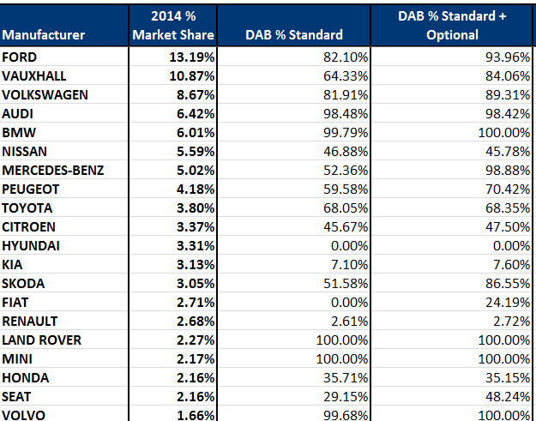

Kilde: CAP.
Digital Radio UK, jan 2015.

